Development of an Android Location Tracking App

Mark Hahn

Colorado State University Global Campus

CSC475

Professor Thakkar

8/14/24

Development of an Android Location Tracking App

The primary purpose of the location tracking application is to demonstrate the integration of Android's location-based services in a mobile application. The app continuously tracks the user's location and updates their position on a Google Map, providing real-time feedback. This functionality is crucial for applications that require location awareness, such as navigation, delivery tracking, or location-based reminders. By developing this app, the project aimed to deepen the understanding of Android's location services and how they can be effectively utilized in mobile applications.

## Development Process, Challenges, and Skills Acquired

The creation of the location tracking application entailed a multifaceted approach, beginning with setting up the Android project framework and integrating essential components such as Google Maps and location services. The development adhered to contemporary Android best practices, including the Model-View-ViewModel (MVVM) architectural pattern to enhance code maintainability and separation of concerns. A notable challenge arose from the deprecation of the traditional ‘LocationRequest’ API, necessitating a transition to the updated ‘LocationRequest.Builder’ API Google Developers (2024). This shift required meticulous code refactoring to align with the latest Android guidelines, ensuring both compatibility and future-proofing of the application. Additionally, managing runtime permissions, particularly for location access post-Android 6.0 (API level 23), presented complexities in balancing user privacy with functional requirements. Implementing dynamic permission requests and handling varied user responses demanded a thorough understanding of Android's permission model.

Throughout this development journey, several key skills were honed. Further proficiency in Kotlin was deepened, especially in navigating API deprecations and integrating modern Android functionalities. The project provided practical experience with Android's location-based services, enhancing the ability to implement real-time tracking and mapping features effectively. Moreover, the necessity to manage runtime permissions dynamically reinforced best practices in ensuring user-centric application design Android Developers (2024). The challenges faced and overcome during this project not only bolstered technical acumen but also underscored the importance of adaptability and continuous learning in the rapidly evolving landscape of mobile application development.

**Screenshot**

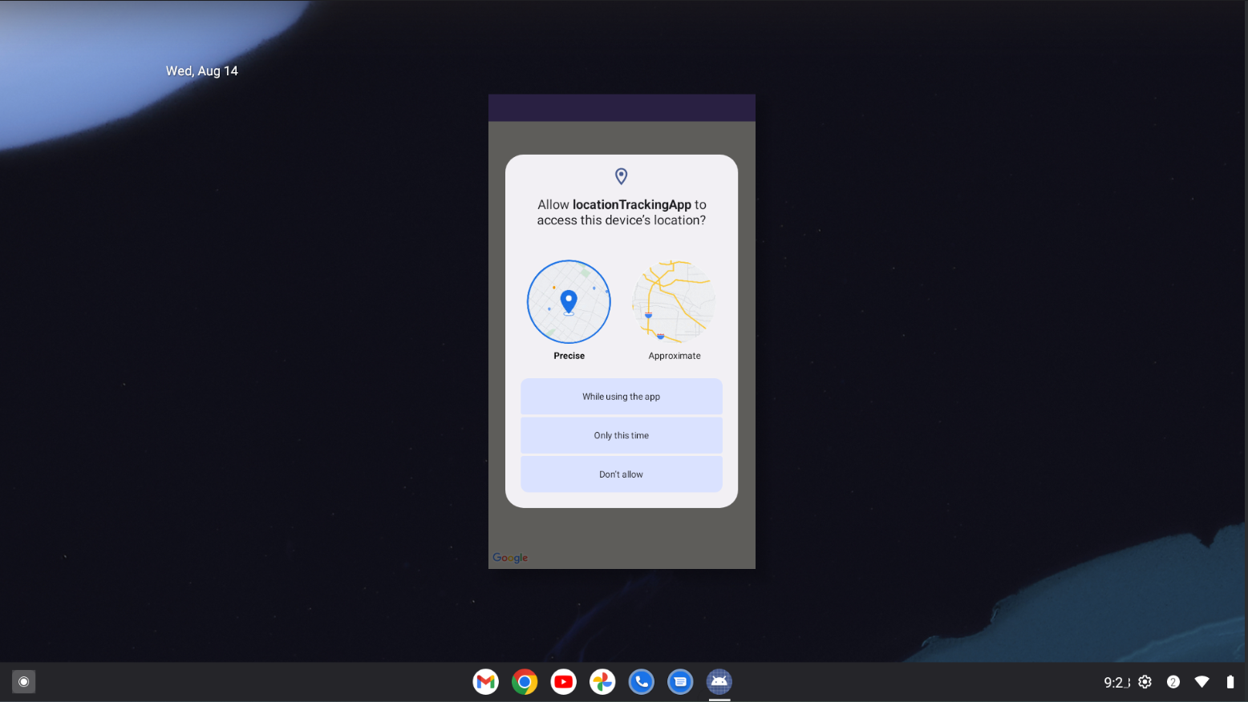

*Image of Location Tracking Application Running*

# Conclusion

Developing the location tracking application was a comprehensive exercise in Android development, covering a wide range of concepts from UI design to backend services. The project not only demonstrated the integration of location-based services but also highlighted the importance of keeping up with evolving APIs and best practices. The skills acquired through this project, particularly in Kotlin programming and Android development, are foundational for any future mobile development endeavors. Overall, the project provided a deeper understanding of how to create robust, user-friendly applications that leverage modern mobile technology.

# References

Google Play services. (2024). LocationRequest. *Developers.Google.com.* Retrieved from [LocationRequest | Google Play services | Google for Developers](https://developers.google.com/android/reference/com/google/android/gms/location/LocationRequest#constant-summary)

Android Developers. (2024). Permissions on Android. *Developer.Android.com.* Retrieved from [Permissions on Android | Android Developers](https://developer.android.com/guide/topics/permissions/overview)